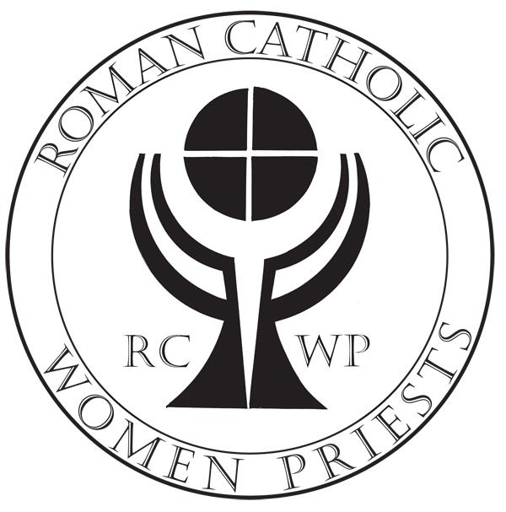
APPLICATION
Roman Catholic Womenpriests-USA, Inc.

There are three parts to the initial Application Process. See Directions at the end of this Application.
After these steps have been completed you will be helped through the additional steps of the application process by the Preparation Program team before you are admitted as a Candidate.

Full Name (first, middle, last)____________________________________________

I need to be Catacomb (confidential)—My Catacomb Name and email are:
CATACOMB NAME________________________________________________
CATACOMB EMAIL_______________________________________________
(I understand that as a catacomb applicant my personal information will be kept confidential and my catacomb name and email will be used during my preparation program until I indicate differently.)

Street Address_________________________________________________

City____________________________State________________Zip______________

Home Phone_____________________Cell Phone_________________________

Email Address______________________________________________________

Date of Birth____________________Place of Birth_______________________
Regional Affiliation____East___West___Midwest___Great Waters___South

Required Releases (please initial)

I understand that my affiliation with Roman Catholic Womenpriests-USA, Inc. may put me at risk with any affiliation I may have with a Roman Catholic diocese. _______

I understand that my individual ministries are separate and independent of RCWP-USA, Inc. and that Roman Catholic Womenpriests-USA, Inc. disclaims any responsibility for the operation or oversight of my ministries. _______

Updated 8-6-18

Roman Catholic Womenpriests-USA Application-2-

Required Releases Cont.
I give my permission to Roman Catholic Womenpriests-USA, Inc. to release all of the above
personal information to the RCWP-USA leadership and the Preparation Program team members for their use in the day-to-day operations of RCWP-USA, Inc. (Catacomb Candidates: If a pseudonym (catacomb name) is used, my official name will be held in confidence.) ________

I understand that my Program of Preparation is a discernment process for me and for the RCWP-USA regional leadership in order to determine my suitability and readiness for ordination. I
further understand that at no time am I guaranteed ordination to the Roman Catholic diaconate
and/or priesthood by RCWP-USA bishops. _______

I consent to the exchange of information provided by all persons, institutions, licensing agencies, federal and state governmental bodies with which I have been associated that are material to evaluating and monitoring my professional practices, qualifications, competencies, ethics and morality. I further understand that such information may be shared with my RCWP Regional Preparation Program Team, and if deemed necessary, exchanged with other representatives of RCWP-USA, Inc., including its Board of Directors. I also understand that RCWP-USA, Inc. will rely upon all information collected during my application process, as well as the units of study completed during my Program of Preparation and Discernment to assess my readiness for ordination, both to the diaconate and to the priesthood.________

Please answer Yes or No to the following questions:

- Have you ever been convicted of or charged with a crime (other than a misdemeanor or minor traffic infraction) in any state or country, the disposition of which was other than acquittal or dismissal? Yes_____ No____

- Has any certifying or licensing board or professional ethics body in any state or country ever required you to surrender your license or certificate or found you guilty of a violation of ethics codes, professional misconduct, unprofessional conduct, incompetence or negligence (including alternative dispute resolution cases)? Yes_____ No____

- Are there any complaints, charges or investigations by any certifying or licensing board or professional ethics body pending against you in any state or country for violation of ethics codes, professional misconduct, unprofessional conduct, incompetence or negligence (including alternative dispute resolution cases)? Yes_____ No____

- Have you ever had any insurance company decline, cancel, refuse to renew or accept only on special terms any professional liability insurance? Yes_____ No____

- Has any professional liability claim or suit ever been made against you (including alternative dispute resolution cases)? Yes_____ No____

6. Are there any circumstances of which you are aware that may result in any professional liability claim or suit being made against you (including alternative dispute resolution cases)? Yes_____ No____

Updated 8-6-18

Roman Catholic Womenpriests-USA Application-3-

7. Have you ever been accused of sexual misconduct or sexual abuse with any minor child or your current or former clients, including but not limited to, spiritual direction clients, mental health clients, or any other persons with whom you have had a professional, pastoral or other similar relationship of confidence and trust, or with any current or former client’s spouse or with any person in a close personal relationship to the client or former client (for example, a guardian, blood relative or the client or spouse of any person sharing the client's domicile)? For purposes of this inquiry, “client” shall include, but is not limited to, persons with whom you have or have had, at any time, any professional, or any other pastoral relationship.
Yes_____ No____

If you have answered yes to any of the above questions, please attach documentation including the final disposition.

RELEASE OF INFORMATION
Roman Catholic Womenpriests-USA, Inc. neither assumes nor accepts responsibility for the actions and practices, nor for the results there from, of any of its applicants. The applicant hereby represents that to the best of her (his) knowledge the statements set forth herein are true. If the information supplied herein changes at any time the applicant agrees to immediately notify the leadership of RCWP-USA of the changes so that at all times RCWP-USA will have accurate and current information.

I recognize that my initial application to Roman Catholic Womenpriests-USA, Inc. is based on the above representations, and my signature below indicates my understanding of and agreement to the releases and standards stated in this Application.

I AGREE TO THESE RELEASES

Name: (please print):__________________________________________

Signature: __________________________________________________

Date: ___________________

Directions for Completing the Application
Applicant:
1. Complete Application and Email to Program Coordinator:
Name of PC__________________________________________(name and Email)

2. Email copy of Application for Master-list to:
Suz Thiel suzthiel@yahoo.com

3. Complete Praesidium Authorization/Disclosure form.
Mail the form and a non-refundable check (made out to RCWP-USA)
in the amount of $75.00 to:
RCWP-USA
PO Box 26402
St. Louis Park, MN 55426

Updated 8-6-18

