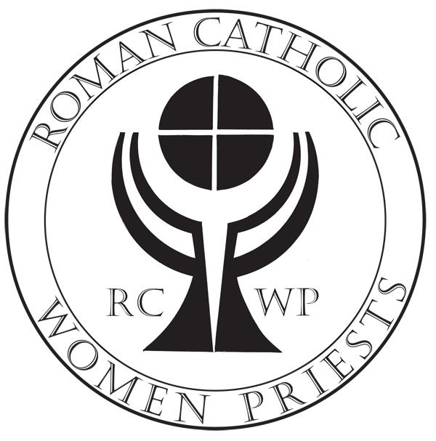
WAIVER AND RELEASE OF INFORMATION
Roman Catholic Womenpriests-USA, Inc.
There are two additional steps to the final process to become a RCWP-USA Candidate:
- Complete this Waiver and Release and email to the persons as indicated in the Directions on page 3.
- Sign the RCWP-USA Constitution and Code or Ethics Signature Agreement and send with this Waiver and Release form to the Program Coordinator as indicated in the Directions on page 3.

Full Name (first, middle, last)_________________________________________

I need to be Catacomb (confidential)—My Catacomb name and email are:
CATACOMB NAME:_______________________________________________
CATACOMB EMAIL:______________________________________________
(I understand that as a catacomb my personal information will be kept confidential and my catacomb name and email will be used during my preparation program until I indicate differently.)

Street Address______________________________________________________

City____________________________State________________Zip______________

Home Phone_____________________Cell Phone_________________________

Email Address______________________________________________________

Date of Birth____________________Place of Birth_______________________

Regional Affiliation:____East___West___Midwest___Great Waters___South

Required Releases (please initial)

I understand that my affiliation with Roman Catholic Womenpriests-USA, Inc. may put me at risk with any affiliation I may have with a Roman Catholic diocese. _______

I understand that my individual ministries are separate and independent of RCWP-USA, Inc. and that Roman Catholic Womenpriests-USA, Inc. disclaims any responsibility for the operation or oversight of my ministries. _____

Updated 12.14.17

Roman Catholic Womenpriests-USA Waiver and Release Cont -2-
Required Releases Cont.

I give my permission to Roman Catholic Womenpriests-USA, Inc. to release all of the above
personal information to RCWP-USA leadership and the Preparation Program team members for their use in the day-to-day operations of RCWP-USA, Inc. (Catacomb Candidates: If a pseudonym (catacomb name) is used, my official name will be held in confidence.) ________

I give my permission to have my name and email address placed on the RCWP Business List at Googlegroups (emails for business communication with RCWP-USA members).
(If I am a catacomb candidate my catacomb name and email will be used.)_______

I give my permission to have my name and email placed on the RCWP Chat List at Yahoogroups (emails for news, discussions and chats with members of RCWP-USA, Association of Roman Catholic Women Priests, RCWP-Canada East, RCWP-Canada West, RCWP-Europe West, and Weiheämter für Frauen in der Römisch Katholischen Kirche.)***Optional______

I understand that I am invited onto the Chat and/or Business lists to communicate with respectful and courteous language at all times, recognizing that the views of other members may be different than my own. ________

I give my permission to have my name and email placed on the RCWP Action Network
(The Action Network are members who respond to social justice issues---individuals’ names are not published to the media.)______

I give my permission to Roman Catholic Womenpriests-USA, Inc. to release the above personal information to the general membership through the RCWP Worldwide Directory and I understand that the Directory is confidential and not to be shared with anyone outside of the international Roman Catholic Womenpriests movement. (If I am a catacomb candidate my catacomb name and email will be used.)***Optional________

I give my permission to Roman Catholic Womenpriests-USA, Inc. to use my name and likeness in photographs, video or audio in any and all of its publications and other promotional materials, including but not limited to the RCWP-USA website, Facebook entries, social media posts, displays, and printed materials, without compensation or payment. ***Optional________

For Catacomb Members: I will need to have my image protected until such time as I have reclaimed my name and identity. ______

I understand that the RCWP-USA name and the RCWP-USA Logo are not to be used in reference to my individual ministries, ministerial events, or on business cards and or in advertisements, referring to my ministries per se. ______
It is acceptable for an RCWP-USA member to advertise saying something to the effect that “Mary Jane Doe is a Roman Catholic Womenpriest who will preside at mass at St. Praxedes Catholic Community.” It is not acceptable for St. Praxedes Catholic Community to be advertised as “St. Praxedes a Roman Catholic Womenpriest-USA Community.” Thus, the RCWP-USA logo and name are not to be used in reference to an individual’s ministry, ministerial event, or in advertisements referring to the ministry per se.

I understand that I may not sign contracts or represent RCWP-USA, Inc. without the approval of the Board of Directors and/or my regional administrator. ______ Updated 12.14.17
Roman Catholic Womenpriests-USA Waiver and Release Cont -3-

Required Releases Cont.

I understand that my Program of Preparation is a discernment process for me and for the RCWP-USA regional leadership in order to determine my suitability and readiness for ordination. I
further understand that at no time am I guaranteed ordination to the Roman Catholic diaconate
and/or priesthood by RCWP-USA bishops. ______

RELEASES OF INFORMATION
Roman Catholic Womenpriests-USA, Inc. neither assumes nor accepts responsibility for the actions and practices, nor for the results there from, of any of its applicants. The applicant hereby represents that to the best of her (his) knowledge the statements set forth herein are true. If the information supplied herein changes at any time the applicant agrees to immediately notify the leadership of RCWP-USA of the changes so that at all times RCWP-USA will have accurate and current information.

I recognize that my candidacy and continued participation with Roman Catholic Womenpriests-USA, Inc. is based on the above representations and my signature below indicates my understanding of and agreement to the releases and standards stated in this Waiver and Release.

I AGREE TO THESE RELEASES

_____________________________________________________________________________
Name (please print):

Signature:
________________________________________________________________
Date:

Directions for Completing the Waiver and Release Form

- Email a copy of this completed Waiver and Release to Suzanne Thiel at
suzthiel@yahoo.com and Pat Sandall at patsysandall@yahoo.com

- Mail a copy of this signed Waiver and Release and a signed copy of the RCWP-USA Constitution and Code of Ethics Signature Agreement to your Program Coordinator:______________________________________________________
________________________________________________________________

Re: Catacomb (Confidential) Members: At any time if a member wishes to rescind their catacomb status, a new Waiver/Release Form will need to be completed and the above steps followed again. *Being on the Chat-list is optional and not required in order to be in the Directory or counted in statistical information.

SIGNATURE AGREEMENT
CONSTITUTION AND CODE OF ETHICS
ADMITTANCE TO CANDIDACY

Roman Catholic Womenpriests-USA, Inc.

On this day, _____________________________ ,
(date)

I, _______________________________________________________ ,
(print name)
indicate, by affixing my signature hereto, that I will abide to follow the Constitution of Roman Catholic Womenpriests-USA, Inc., which was ratified on April 2, 2012.

I understand that I am responsible to follow the Code of Ethics in Section 12 of this Constitution and that my membership in Roman Catholic Womenpriests-USA, Inc. is subject to my adherence to the principles in this Code.
Corrective action by my Regional Leadership Team and/or the Board of Directors Circle may be taken in various forms, from verbal and/or written counsel up to and including removal from membership in RCWP-USA.

________________________________________________________
(Print Name)

_________________________________________________
(Signature)

Directions for Completing the Signature Agreement

Mail a copy of this signed Signature Agreement with your Waiver and Release to your Program Coordinator.

